ultramirinc.champs_mood

Class MyAdapterSchedule

java.lang.Object android.support.v7.widget.RecyclerView.Adapter<MyViewHolderSchedule>

ultramirinc.champs_mood.MyAdapterSchedule



public class MyAdapterSchedule

extends android.support.v7.widget.RecyclerView.Adapter<MyViewHolderSchedule>

Created by William on 2017­04­13. This class makes the transition between the raw data and a visual interpretation for the user's breaks

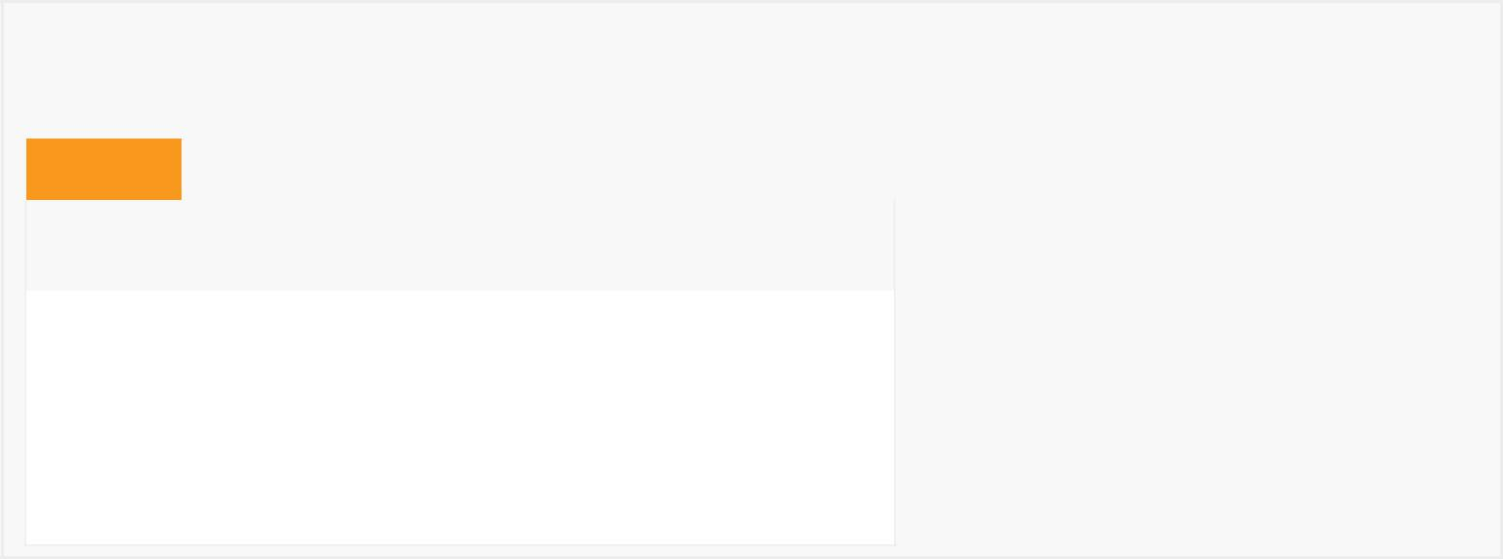

*Field Summary*

Fields

|  |  |
| --- | --- |
| Modifier and Type | Field and |
|  | Description |

(package private) java.util.List<Break> list

Contains the list of the schedule's breaks

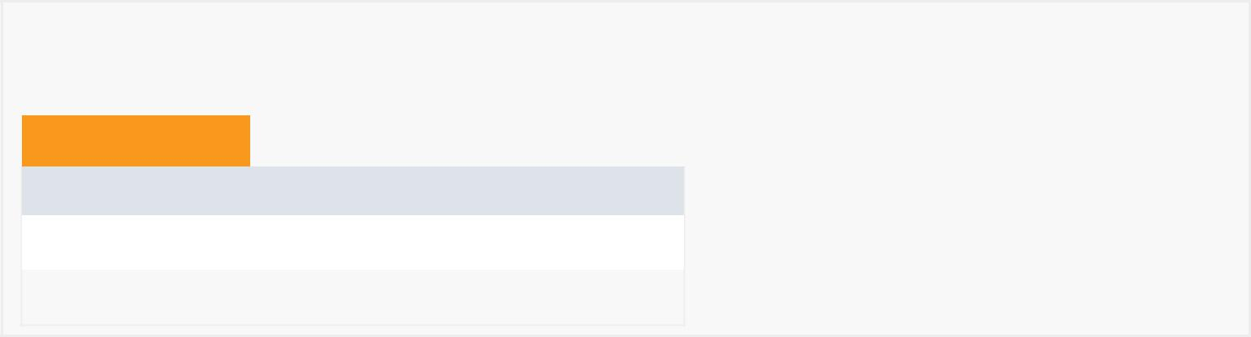

*Constructor Summary*

Constructors

Constructor and Description

MyAdapterSchedule()

MyAdapterSchedule(java.util.List<Break> list)

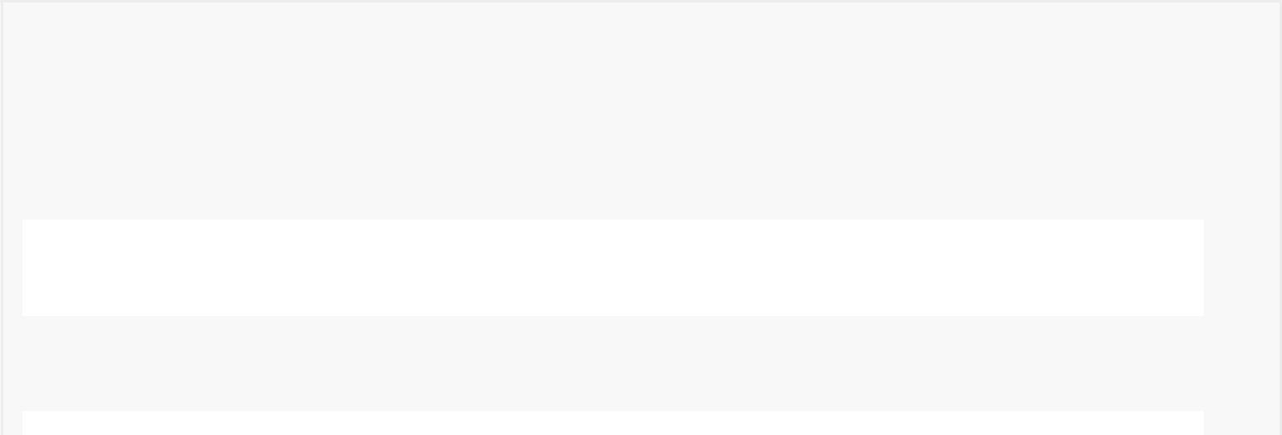

*Method Summary*

|  |  |  |  |  |  |  |  |
| --- | --- | --- | --- | --- | --- | --- | --- |
|  | All Methods |  |  | [Instance Methods](javascript:show(2);) |  | [Concrete Methods](javascript:show(8);) |  |
|  | Modifier and Type | | | Method and Description | | | |
|  | private void | | | deleteBreakFromDb(Break breakToDelete) | | | |
|  |  |  |  | Deletes a break. | | | |
|  |  |  |  |  |  |  |  |
|  | int | | | getItemCount() | | | |
|  |  |  |  | Returns the size of the list. | | | |
|  |  |  |  |  |  |  |  |

void onBindViewHolder(MyViewHolderSchedule myViewHolderSchedule,

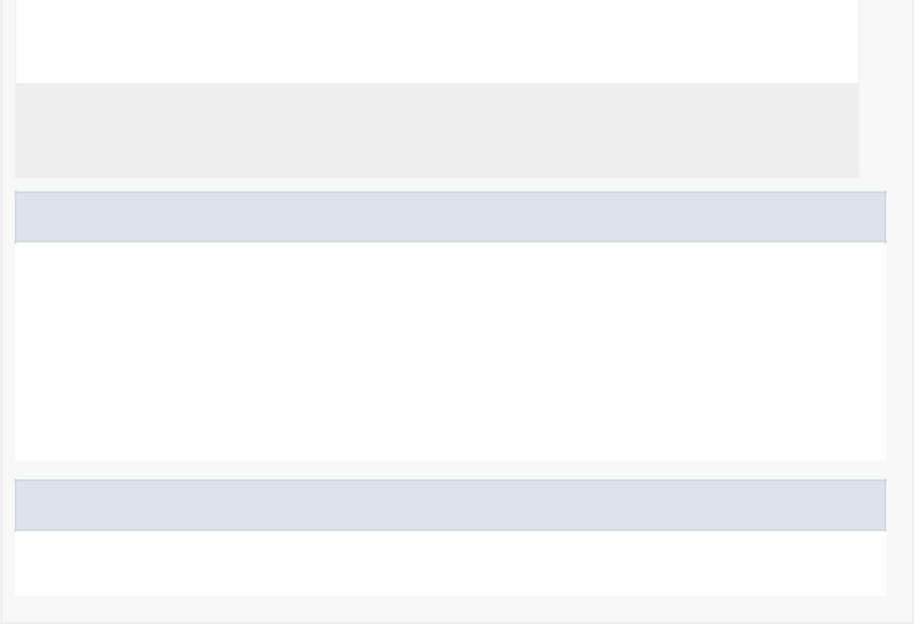

int position)

Binds the information from a given break with the ViewHolder.

MyViewHolderSchedule onCreateViewHolder(android.view.ViewGroup viewGroup, int itemType)

Creates a Visual interpretation using a custom ViewHolder.

Methods inherited from class android.support.v7.widget.RecyclerView.Adapter

bindViewHolder, createViewHolder, getItemId, getItemViewType, hasObservers, hasStableIds, notifyDataSetChanged, notifyItemChanged, notifyItemChanged, notifyItemInserted, notifyItemMoved, notifyItemRangeChanged, notifyItemRangeChanged, notifyItemRangeInserted, notifyItemRangeRemoved, notifyItemRemoved, onAttachedToRecyclerView, onBindViewHolder, onDetachedFromRecyclerView, onFailedToRecycleView, onViewAttachedToWindow, onViewDetachedFromWindow, onViewRecycled, registerAdapterDataObserver, setHasStableIds, unregisterAdapterDataObserver

Methods inherited from class java.lang.Object

clone, equals, finalize, getClass, hashCode, notify, notifyAll, toString, wait, wait, wait

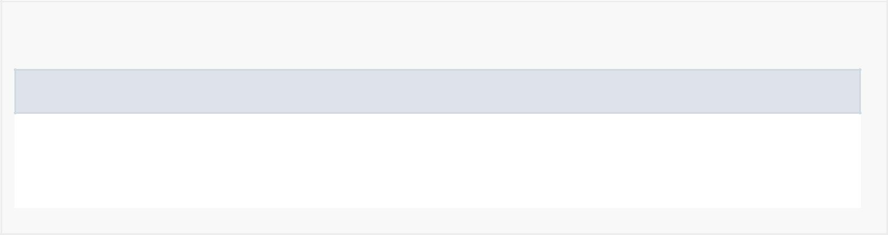

*Field Detail*

list

java.util.List<Break> list

Contains the list of the schedule's breaks

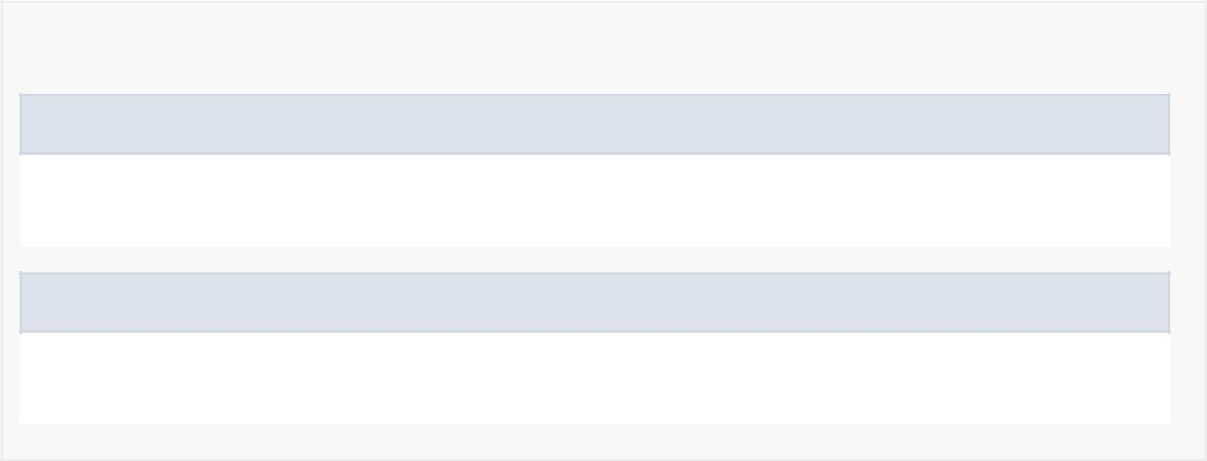

*Constructor Detail*

MyAdapterSchedule

public MyAdapterSchedule(java.util.List<Break> list)

MyAdapterSchedule

public MyAdapterSchedule()



*Method Detail*

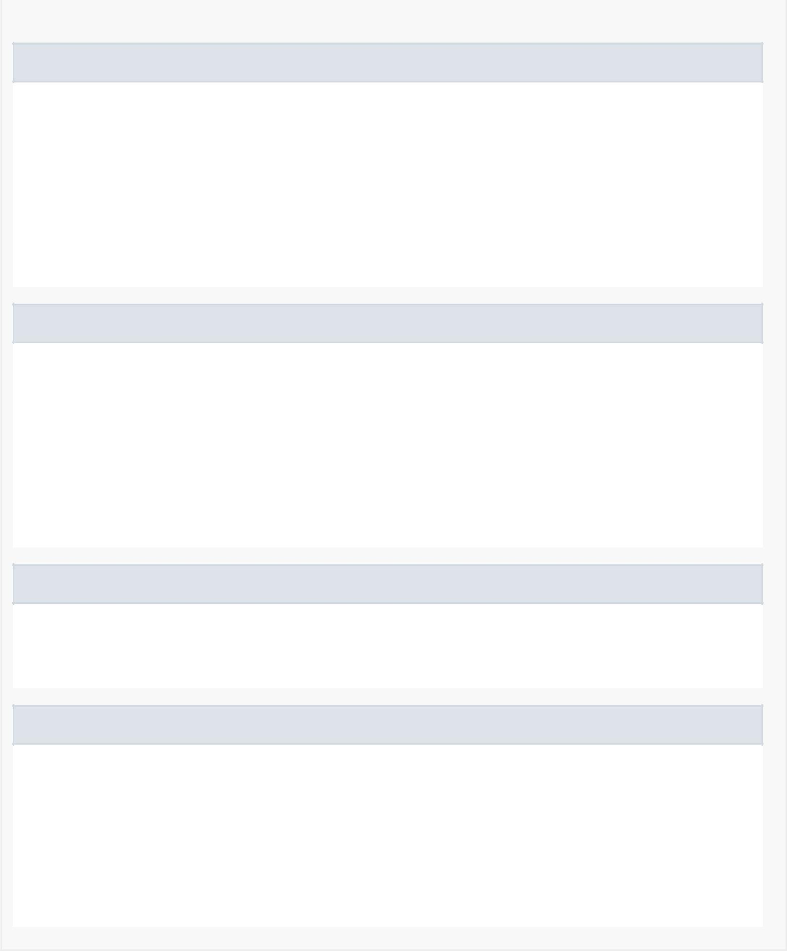

onCreateViewHolder

public MyViewHolderSchedule onCreateViewHolder(android.view.ViewGroup viewGroup, int itemType)

Creates a Visual interpretation using a custom ViewHolder.

Specified by:

onCreateViewHolder in

class android.support.v7.widget.RecyclerView.Adapter<MyViewHolderSchedule>

onBindViewHolder

public void onBindViewHolder(MyViewHolderSchedule myViewHolderSchedule, int position)

Binds the information from a given break with the ViewHolder.

Specified by:

onBindViewHolder in

class android.support.v7.widget.RecyclerView.Adapter<MyViewHolderSchedule>

deleteBreakFromDb

private void deleteBreakFromDb(Break breakToDelete)

Deletes a break.

getItemCount

public int getItemCount()

Returns the size of the list.

Specified by:

getItemCount in

class android.support.v7.widget.RecyclerView.Adapter<MyViewHolderSchedule>